MINDX SERVICE AI

DAY 4 ASSIGNMENT REPORT

Submitted by
Santhoshkumar D
B.Tech Information Technology
Rajalakshmi Engineering College

Date : 08/04/2026

Objective:
To design and develop a complete AI-powered customer support system with user interaction, admin management, ticket tracking, and analytics dashboard using full-stack technologies.

System Overview:
- The system allows users to interact with an AI chatbot that creates support tickets.
- Administrators can monitor, manage, and respond to tickets through a dedicated dashboard.
- The system also provides analytics for tracking performance and ticket trends.
Technologies Used:
- Frontend: React.js
- Backend: Spring Boot (Java)
- Database: MySQL
- APIs: REST APIs
- AI Integration: OpenAI API / Custom AI Service
- Version Control: Git & GitHub

Features Implemented:
1. Authentication System (User & Admin)
- Login system for both User and Admin
- Role-based access control:
  - USER → Chat interface
  - ADMIN → Dashboard
- Credentials stored securely in database
- Session handled using localStorage

2. AI Chat System
- Interactive chat interface
- AI-generated responses based on user queries
- Context-aware conversation using message history
- Auto-scroll and dynamic UI updates

3. Ticket-Based System
- First message creates a ticket automatically
- Each ticket has a unique ID
- All messages linked to the same ticket
- Full conversation history maintained

4. Admin Dashboard
- View all tickets in system
- Sidebar navigation with icons
- Search and filter functionality
- Clean and modern UI

5. Admin Reply System
- Admin can reply to any ticket
- Replies stored as ADMIN messages
- Visible to users in chat interface
- Enables real-time support simulation
6. Status Management
- Ticket status can be updated:
  - OPEN
  - RESOLVED
  - NEEDS_HUMAN
- Dropdown-based status control
- Instant update without extra actions
7. Analytics Dashboard
- Displays key metrics:
  - Total tickets
  - Resolved tickets
  - Escalated tickets
- Charts Included:
  - Monthly ticket trends
  - Daily ticket activity
  - Escalation ratio
  - Status distribution

8. User-Ticket Mapping
- Each ticket linked to a specific user (user_id)
- Ensures data separation and security
- Users can access only their own tickets

System Flow:
- User/Admin logs into the system
- Role-based access is determined
- User sends message → ticket created
- AI generates response
- Messages stored in database
- Admin views tickets in dashboard
- Admin opens ticket → views full chat
- Admin replies and updates status
- User sees updated messages and status

Architecture:
The application follows RESTful API principles ensuring modular and maintainable system design.Controller Layer → Handles API requests
- Service Layer → Business logic
- Repository Layer → Database interaction
- Database → MySQL

Flow:
User → Controller → Service → Repository → Database

Database Design:
The system uses three main tables:
- User Table → Stores login credentials and roles
- Ticket Table → Stores ticket details and status
- Message Table → Stores chat messages (USER, AI, ADMIN)

Screenshots:
Figure 1: Login Page (User/Admin)
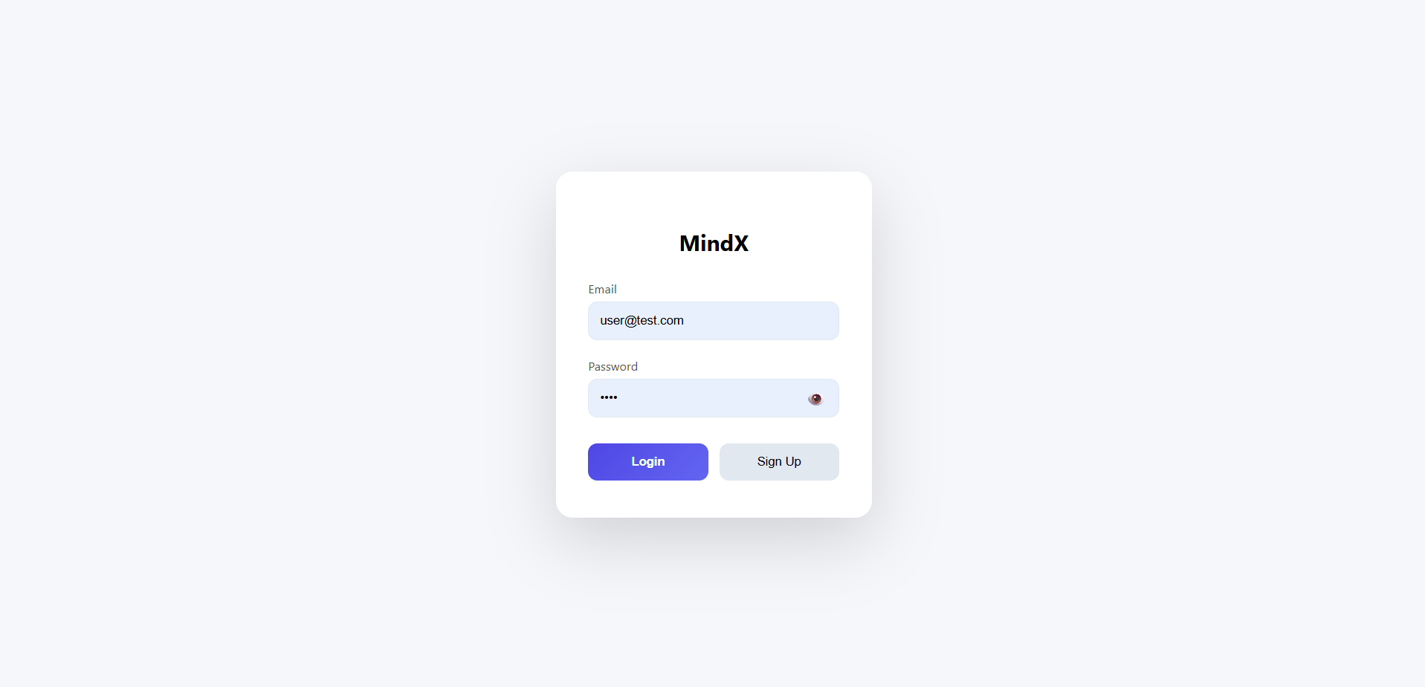
Figure 2.1: Chat Interface
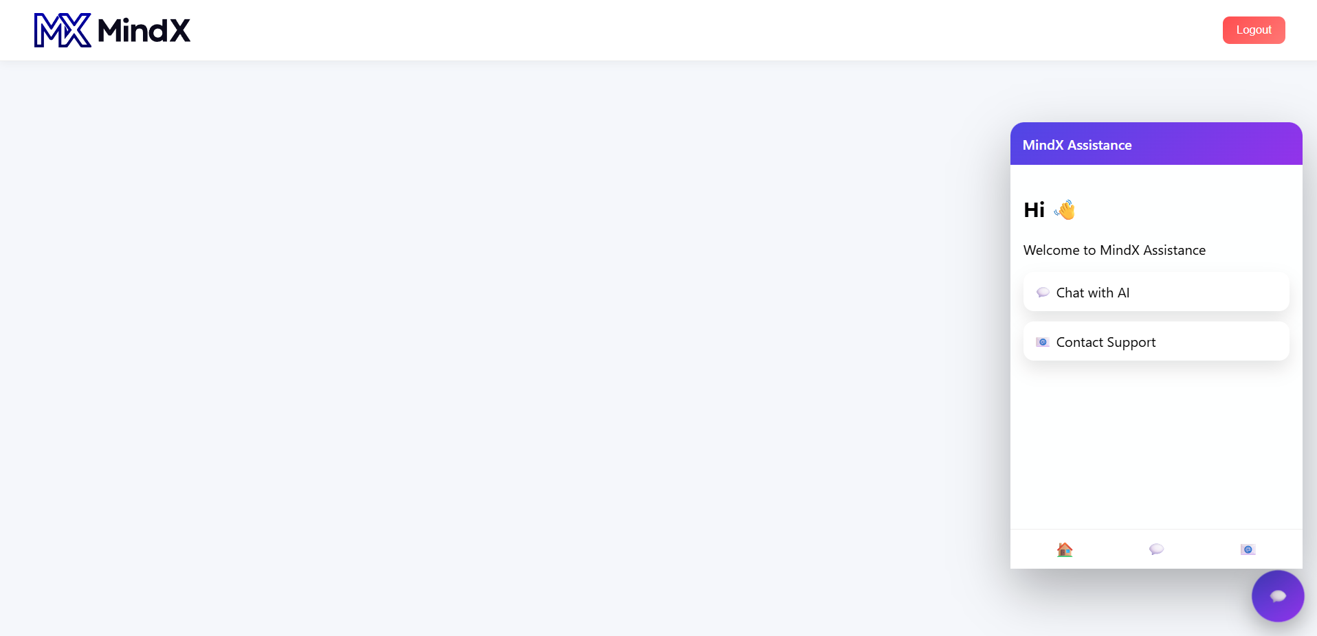

Figure 2.2: Chat Interface
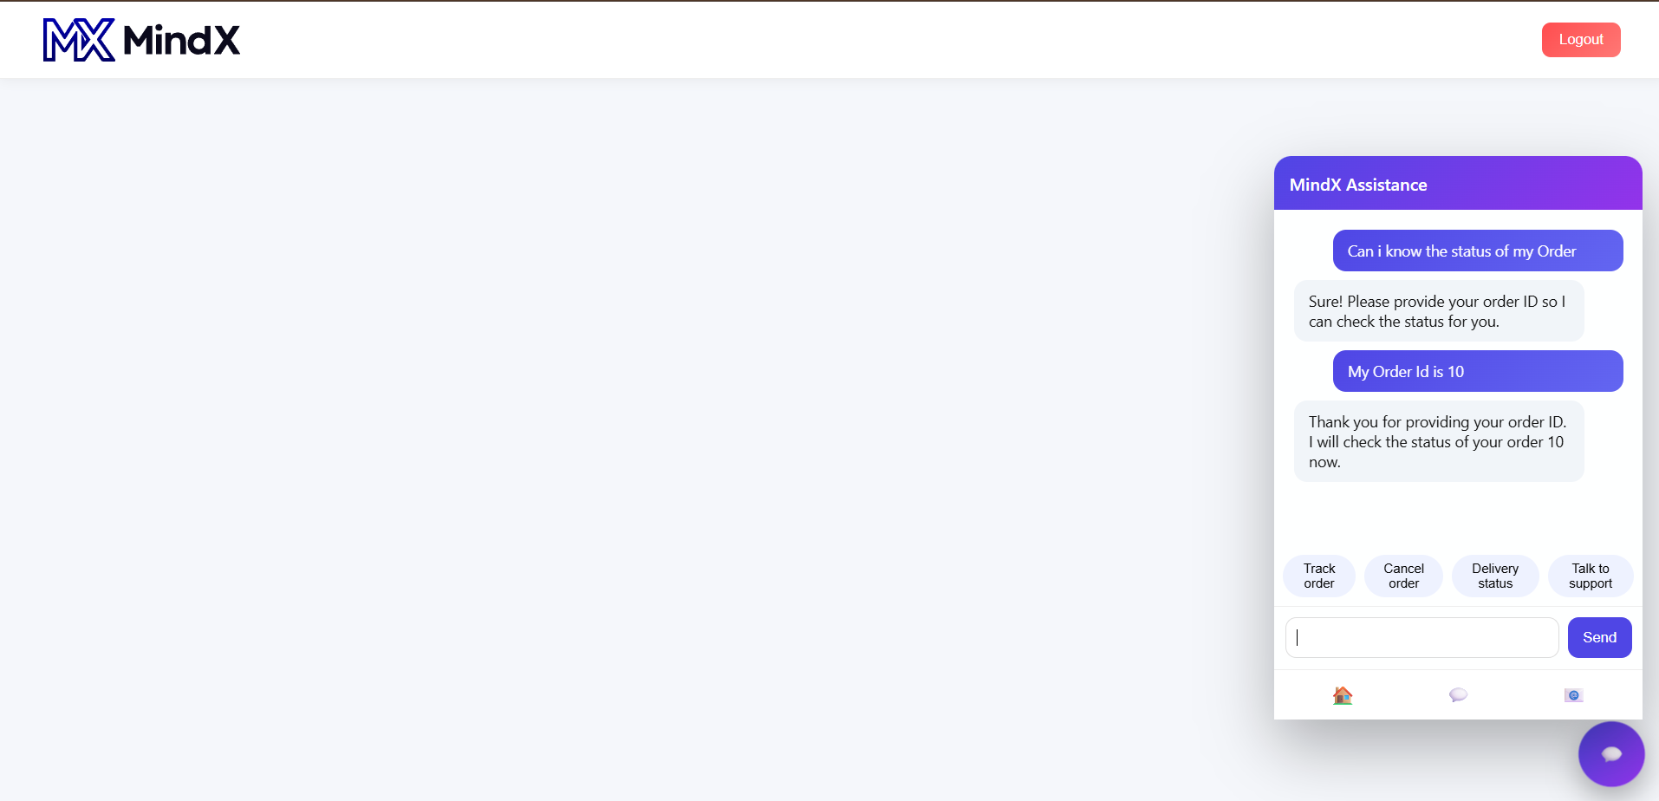

Figure 2.3: Chat Interface
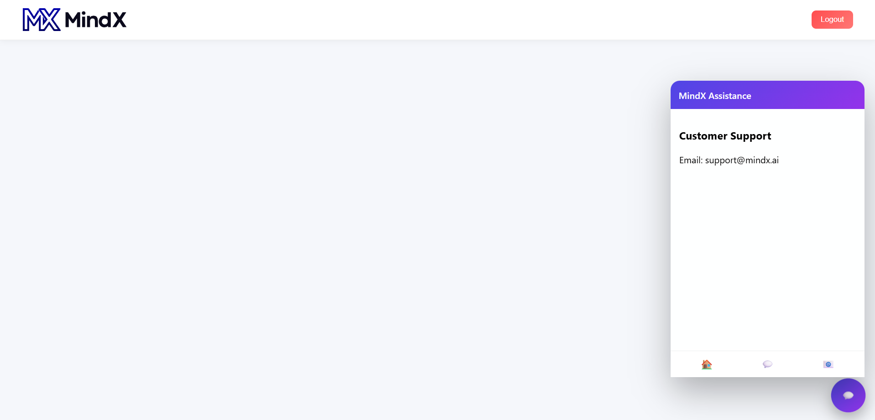

Figure 3.1: Admin Dashboard
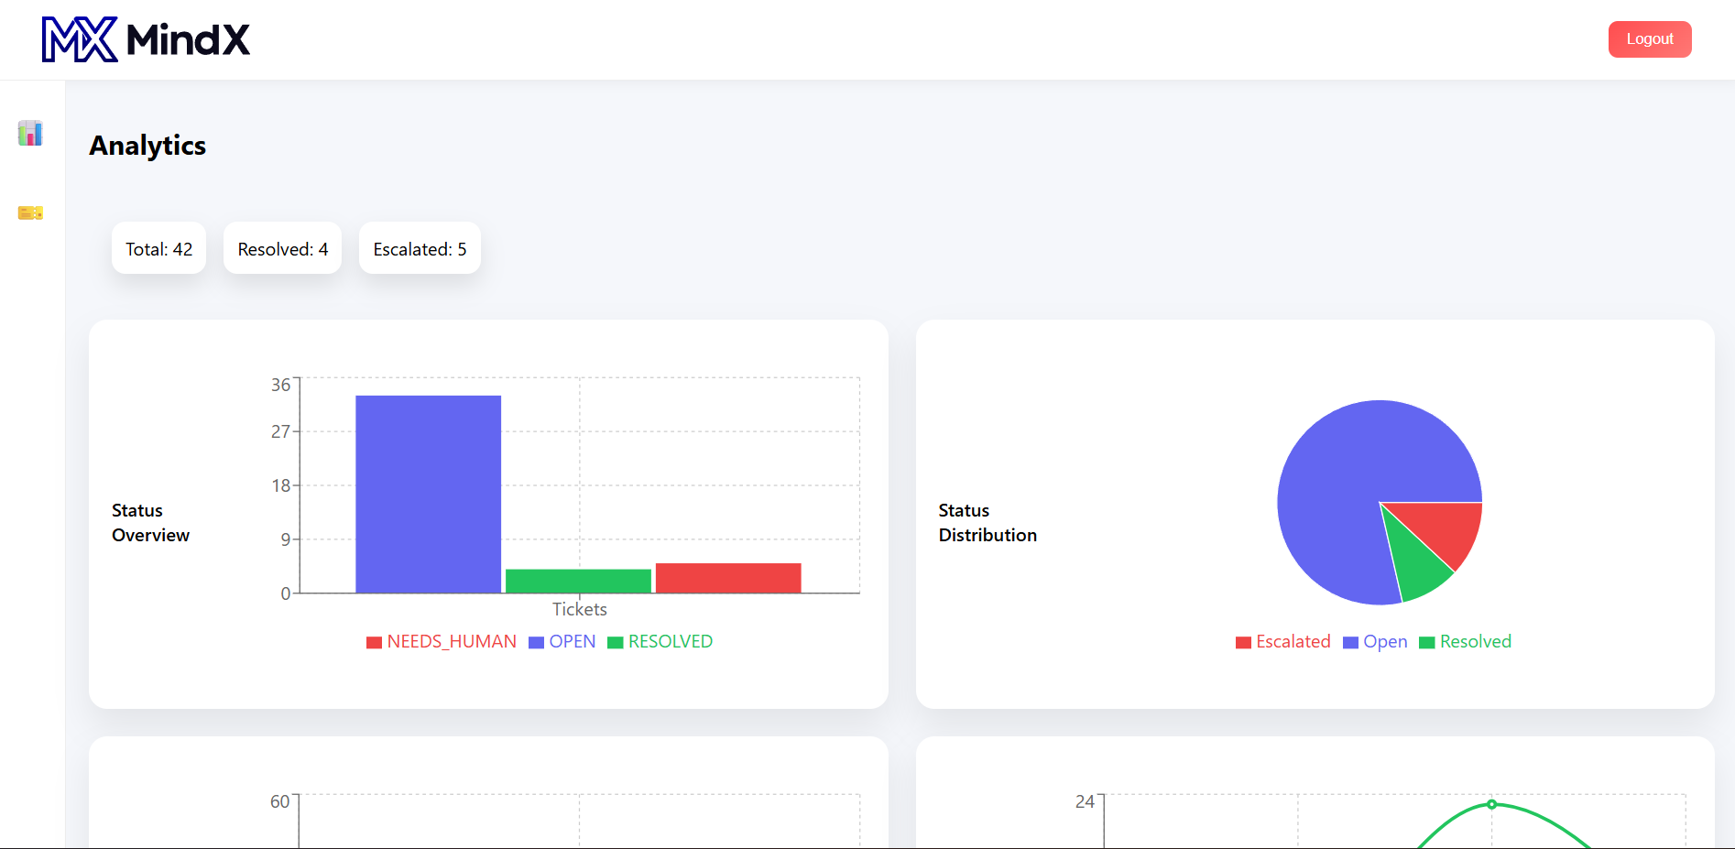

Figure 3.2: Admin Dashboard and Analytics
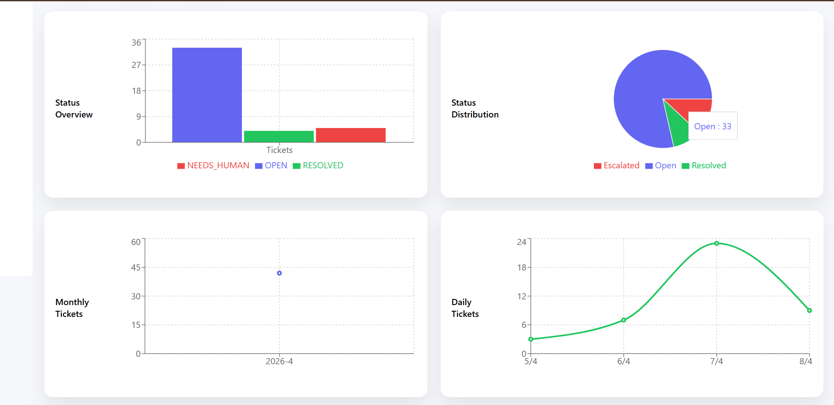

Figure 4.1: Ticket Details
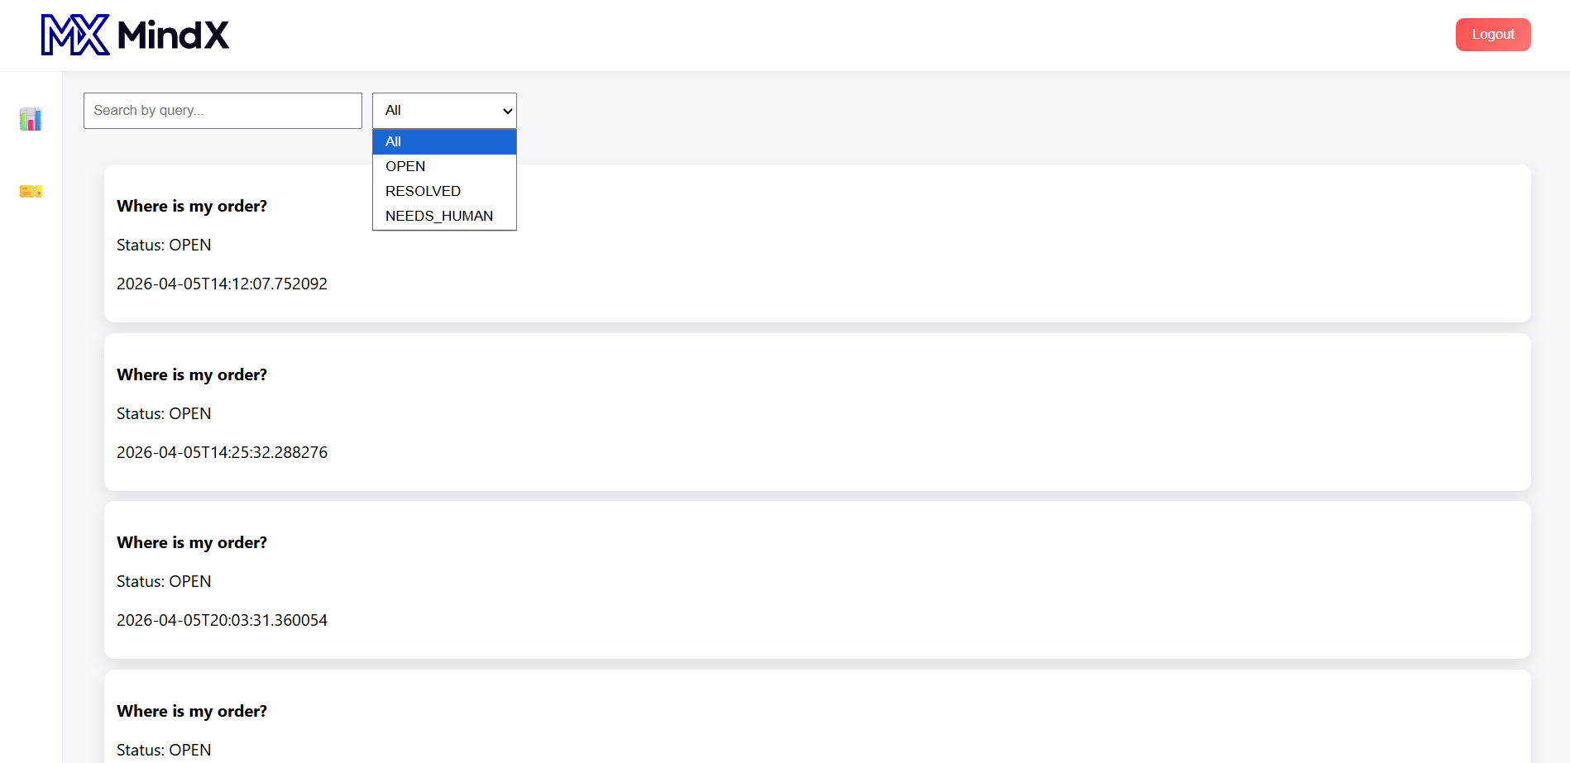
Figure 4.2: Ticket Status change and Admin Reply
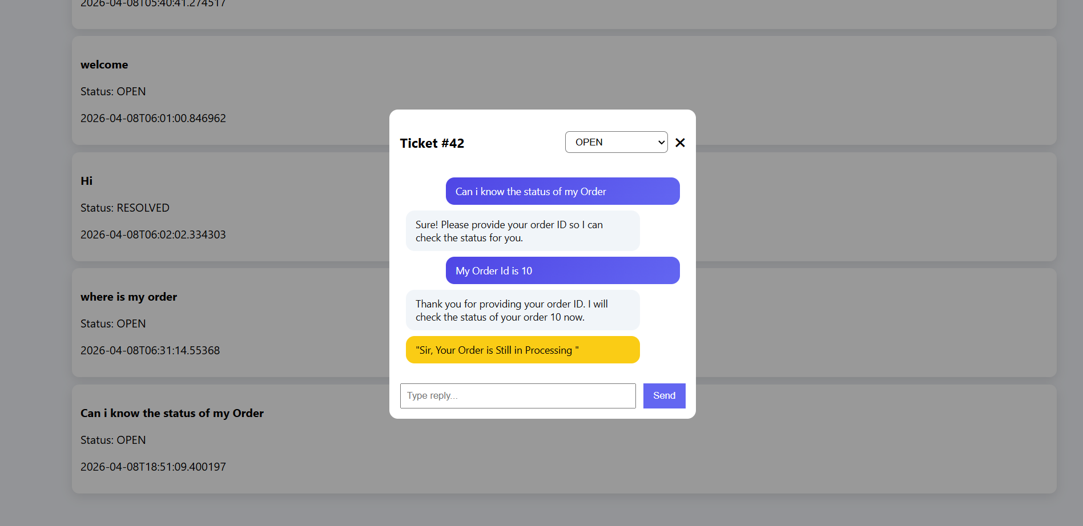

Challenges faced:
- Handling AI response formatting (JSON parsing)
- Managing ticket ID across sessions
- Linking tickets with users (user_id issue)
- Fixing frontend-backend integration errors
- Designing responsive and modern UI

Solution:
- Implemented structured API handling
- Parsed AI response to extract clean messages
- Added userId mapping for tickets
- Improved state management in frontend
- Optimized UI components and layout

Conclusion:
Successfully developed a complete AI-based customer support system with authentication, ticket management, admin control, and analytics. The system simulates a real-world support platform and demonstrates full-stack development, clean architecture, and intelligent response handling. The system is designed with scalability in mind and can be extended to real-time communication using WebSockets.

GitHub Repository:
https://github.com/SANTHOSHDEV22/mindx-support-ai

